

Learner Friendly
Anti-bullying Policy

Hemlock Stone School

Designated Safeguarding Lead: Joanna Repton
Safeguarding Governor: Charlotte Niekirk

  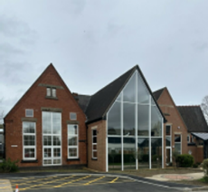 | At Hemlock Stone School, we are kind
 | We take care of each other
   | We have kind words
 | We have kind hands
 | We have kind feet
 | We send kind messages

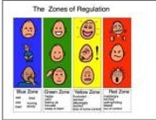 | We can use colours and symbols to show how we are feeling
   | Staff keep us safe
 | We can ask staff for help if we don’t feel safe
 | We all work together to help everyone feel happy
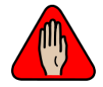  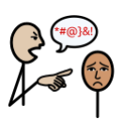 | We say ‘NO’ to bullying

Hemlock Stone School
bullying Policy
Anti -
Pupil Friendly

